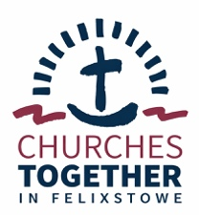
AGM AND FORUM AGENDA
Monday 1st June 2026
At Felixstowe Methodist Church @ Trinity, 26 Hamilton Road IP11 7AN
7.00pm
Refreshments from 6.30pm

AGM
- Welcome
- Attendance & apologies
- Opening Worship
- Acceptance and signing of last year’s AGM minutes held 12th May 2025
- Matters Arising
- Reports & Policies
  - Moderator’s report – Rev Penny Brinkley
  - Financial Report – Angela Barbrook (treasurer)
    - Appointment of examiner of accounts
  - Acknowledgement of Reports from Organisations supported by CTIF
(these are all available on the website to read)
  - Safeguarding Policy and appointment of Safeguarding Officer
  - New Policies
  - Adoption of the new polices
  - Election of officers
  - Steering group committee

Forum
- Acceptance and signing of the minutes of the Forum held 10th November 2025
- Matters arising
- Felixstowe Fairtrade
- Josh Geddis-Pile, Chaplain to QVSR, Seafarer’s Centre
- Closing Worship

Telephone 01394 279368 secretary@churchestogetherfelixstowe.org

